Bickerstaffe Primary School

Forest School Handbook
Contents

Introduction

- Staff

- Roles and Responsibility

Forest School Policies and Procedures overview

- Safe Guarding

Policies

Forest School at Bickerstaffe

At Bickerstaffe Primary School our vision is that over the next few years we will enhance the profile and provision of our Outdoor Learning to provide specialist Forest School sessions to children across the school. This will create a chance to:
- Connect with the natural world
- Deliver first hand experiences of life and growth
- Explore endless opportunities for creativity and imagination
- Improve physical, social and emotional development.

Outdoor Learning improves children’s emotional health, allowing for relaxation and calmness and a heightened sense of well-being. It can provide opportunities for independent learning, building confidence, resilience and self-esteem. With this focus, we will ensure that through tailored Forest School activities, these needs will be met.

Two members of staff are also working towards gaining their Level 3 Forest School Practitioner qualification which will allow the use of tools and open fires within the school setting. This course entails a 5 day practical training course and a day practical assessment alongside which a substantial portfolio will be completed. Trainees are also required to attend and pass a 2 day Outdoor First Aid course.

Meet the staff:

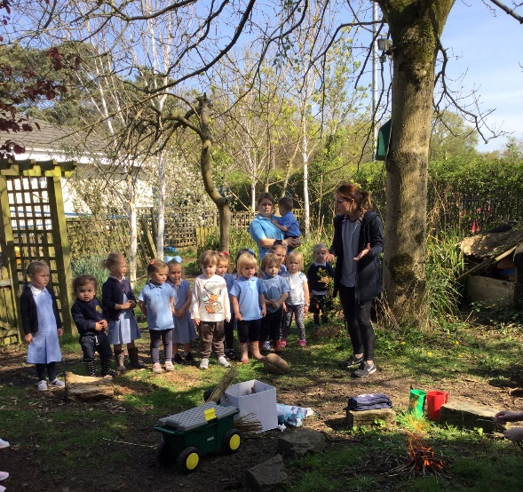

Mrs A. Hunter Reception Teacher

Training to be Level 3 Forest School practitioner.
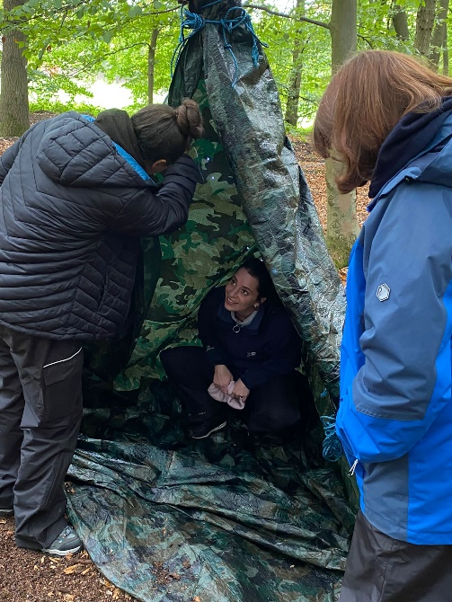

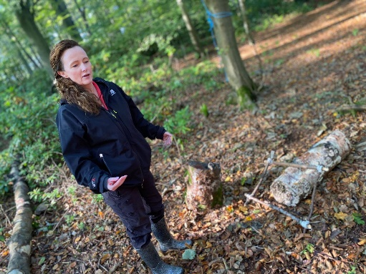

Mrs S Lloyd KS2 Teaching Assistant
Training to be Level 3 Forest School practitioner.

.

Bickerstaffe Primary School Forest School Policy and Procedures

Mission Statement

At Bickerstaffe Primary School we aim to use the natural outdoor woodland area to offer the children an insight into the Forest School ethos. This approach to outdoor learning encourages children to become independent, use their imagination, take appropriate risks within boundaries and initiate learning for themselves.
Forest School is a holistic approach to learning, incorporating children’s individuality and develops their skills for lifelong learning. It can cover all aspects of the EYFS and National Curriculum, including the emotional and spiritual aspects of learning where self-esteem and self-confidence can grow and positive relationships with peers can be formed. Forest School explores the outdoors and the natural environment with practical, useful activities all year round. It develops peer learning with the adults providing support and enabling activities to take place. The child’s interest will be at the heart of any activity.

The main aims of Bickerstaffe’s Forest School are:

- To experience the outdoor environment for an extended period of time developing a relationship with natural spaces.
- To promote children’s self-esteem and confidence using the Forest School area.
- To foster independent, resilient, creative learners.
- To meet the requirements of the EYFS and National Curriculum within each Forest School session

Roles and Responsibilities

Governors
- Ensure they are aware of Forest School ethos, procedures and objectives.
- Ensure they are informed of the health and safety procedures in place for Forest School.

Head Teacher
- Ensure sessions comply with the regulations and guidelines.
- Be confident that the Forest School Leader/Group Leader is competent to monitor the risks throughout each session.

Forest School Leader

The Forest School Leader will have the overall responsibility for the supervision and conduct of each session. The leader will:-
- Be working towards a Level 3 Forest School Leader qualification and an hold an up to date Outdoor First Aid qualification.
- Follow the health and safety guidelines and policies.
- Undertake comprehensive risk assessments.
- Clearly define each adult’s role.
- Be aware of child protection issues.
- Ensure that adequate first aid provision is available.
- Undertake the planning and preparation for each session, including differentiation
for individual children’s needs.
- Ensuring necessary equipment is taken into woodland.
- Supervise the use of tools use, cleaning and storage.
- Organise emergency procedures.

Additional Adults/Volunteers

Other adults will be clear in their roles and responsibilities. They will:
- Do their best to ensure the health and safety of everyone in the group-reminding children of rules and boundaries within the setting and following them themselves at all times
- Follow the instructions of the forest school leader and help with the control and discipline.
- Model good practice throughout the session
- Carry out delegated roles and responsibilities
- Support children to manage their own risk
- Speak to the Headteacher/Forest School leader if concerned about the health and safety of children at any time during the visit.
- Be DBS checked
Parents

The Forest School Leader will:
- Provide parents with written information about Forest School sessions, their aims and objectives.
- Tell parents how they can help prepare their child for the visit.
- Parents will need to Sign a consent form and give the teacher information about the
child’s physical health and medical needs.

Equality and Diversity

All children will be included with all activities and no form of discrimination will take place, reasonable adjustments will be made to make it inclusive for all. Inclusion is a thread which runs through all of the Forest School activities regardless of a child’s ability, disability, gender, race, culture, etc.

Special Educational Needs

- Forest School aims to provide a welcome and appropriate learning opportunity for all children providing an environment in which all children are supported to reach their full potential.
- We welcome children with special needs who can participate in Forest School, if appropriate, after consultation between all relevant parties.
- Changes and adaptations can be made to the programme of activities to meet
children’s specific needs.

Health and Safety

Forest School sessions by their nature encourage children to develop their own risk management skills and will support them to become responsible for themselves and others around them. Children will be reminded of rules and safe play if they are considered too dangerous.
Risk Assessments will be carried out for each activity and for the use of all tools and equipment. A pre-visit site check is also carried out and recorded before each visit. Risk Assessments will be in place to cover other eventualities. The Forest School Leader will assess weather conditions regularly and will evacuate the area if they become too extreme. All children and adults will wear appropriate clothing for the weather conditions. A Forest School Leader will be present at all times and children will be reminded of safe practice

First Aid

- Forest School leaders hold an advanced first aid certificate which specifically covers outdoor first aid.
- They will administer care needed during each session following the First Aid policy already in school and in line with Forest School procedures.
- The Forest School Leader will ensure the safety of every child and will assess the possible need to evacuate the children indoors.
- They will seek emergency help if needed and there will be a first aid kit taken into the woodland area. This will be kept in a place that is accessible to all. Additional first aid equipment is located within school.
- If an accident occurs the parents will be contacted, an accident report form filled in. Minor incidents will be recorded in an accident book which can be located in the Forest School Leaders rucksack along with the first aid kit.
- All staff and helpers are made aware of medical conditions of the children-inhalers, epi pens etc and these are taken into the woodland as needed.

Emergency Procedures

- In the event of a minor injury occurring initial first aid will be carried out by the Forest school leader.
- If it is necessary the child will leave the woodland with an adult to go to the medical room on the school site. In this event a report slip will be sent with the child to notify the school first aider of any details.
- In an emergency the Forest school leader will contact the school by mobile phone ensuring a quick response for emergency services.

Bickerstaffe Primary School Forest School Safe Guarding Guidance

Bickerstaffe Primary School fully recognises its responsibilities for safeguarding children. All staff and volunteers are responsible for keeping children safe. In particular:

- Ensuring all children have a safe environment at Forest School in which to learn and develop.

Ensuring we practice safe recruitment and checking the suitability of volunteers to work with children.
- Raising awareness of child protection issues and equipping children with the skills needed to keep the safe.

Implementing procedures for identifying and reporting cases, or suspected cases, of abuse.
- Supporting pupils who have been abused inn accordance with his/her agreed protection plan.

Staff working in Bickerstaffe Primary School Forest School will follow the school’s Safeguarding and Child Protection Policy. This can be found on the school

Bickerstaffe Primary Forest School Weather Policy and Procedures

Bickerstaffe Forest Schools believes
‘There is no such thing as bad weather, only bad clothing’

The management of Health and safety at work Regulations 1999 requires employers to assess the risks of activities; introduce measures to control these risks and to tell their employees about these measures
So far as reasonably practicable the forest school staff and management will take all reasonable steps to identify and reduce hazards to a minimum.
Forest School is an outdoor ‘classroom’; and as such, weather can be the most influential
element in what and how things happen. Please refer to general weather risk assessment.

Procedures
The Forest Leader is responsible for checking local weather conditions on the morning of a forest school session.

There is no such thing as bad weather…however, wind can be a dangerous element
in a woodland due to potential falling limbs, branches etc... Therefore if there are strong winds (measuring over 5 on the Beaufort scale or above 19-24 mph) or thunder and lightning the session will not take place.

Particular attention to the canopy layer should be paid at the first dynamic risk assessment after strong winds to check for hung up trees/branches and fallen/damaged trees.

All children will wear appropriate clothing before leaving the main school building, this may be; fleece, gloves, wellies, waterproof jacket and coats, sunhats.
Adult helpers are advised to be appropriately dressed and where possible wellies/hats/gloves/spare socks and additional coats will be found if necessary.

Planned themes and activities need to be very flexible and able to be adapted due to weather conditions.
In cold weather children will be more encouraged to be more active. More sedentary activities such as woodland medallions, memory sticks will take place in warmer conditions.

Bickerstaffe Primary School Forest School Food Hygiene Policy
Bickerstaffe Primary Forest School maintains high food hygiene standards in relation to the purchase, storage, preparation and serving of food.

A full Activity Risk Assessment will be completed for any activity involving the preparing and/or consuming of food items. This will include attention to the purchase, storage, preparation and serving of any food items to prevent growth of bacteria and food contamination.

Food/ingredients will be stored at correct temperatures prior to the session and checked to ensure they are in-date and not subject to contamination by pests, mould etc. A cool box will be used to transport and store any ingredients requiring refrigeration prior to use at the Forest School site. All such ingredients must be used within 2 hours.

When food items are to be consumed during a Forest School session, warm water with anti-bacterial soap in a bowl will be provided for hand-washing together with anti-bacterial had sanitiser.
Children and adults will be required to wash their hands immediately prior to preparing any food items and/or eating.

All medical records must be checked to ensure that no food item or ingredient is given to a child or adult with an allergy to it.

Cooked food will not be re-heated.

Campfire Cooking Policy

The Food Hygiene Policy will be followed whenever cooking on a campfire.

Campfire cooking will be done under the close supervision of a Forest School Leader.

An activity Risk Assessment will be completed for all activities involving cooking on the campfire. All hair will be tied back and loose clothing secured prior to cooking on a campfire.

