Prior Knowledge:
(Cycle B) Use range of media, demonstrating increased control. Develop observational skills to look closely and reflect surface texture through mark-making. Experiment with drawing on different surfaces, and begin to explore tone using a variety of pencil grade (HB, 2B, 4B) to show form, drawing light/dark lines, patterns and shapes.
Bickerstaffe CE Primary
Autumn 1 Class 2 Year 1
Art and Design – Drawing

Substantive Knowledge | Disciplinary Knowledge | Key Vocabulary
What we will learn: | How we will learn: | Key words:
We will learn the language and literacy to describe lines.  We will show control when using string and chalk to draw lines.  We will learn how to experiment with a range of mark-making techniques.  We will learn how to colour neatly and carefully, featuring a range of different media and colours.  We will learn how to apply a range of marks successfully to a drawing.  We will produce a drawing that displays observational skill, experimenting with a range of lines and mark making. | We will explore their own ideas using a range of media.  We will use our sketchbooks to explore ideas.  We will develop some control when using a wide range of tools to draw, paint and create crafts and sculptures.  We will make choices about which materials to use to create an effect.  We will develop observational skills to look closely and reflect surface texture.  We will understand how artists choose materials based on their properties in order to achieve certain effects.  We will describe and compare features of their own and others’ artwork.  We will evaluate art with an understanding of how art can be varied and made in different ways and by different people.
  Geometric | Mathematical shapes with straight lines and angles
  Horizontal | Flat or level with the ground and not at an angle to it
  Irregular | When shapes or lines are not formed of the same sizes
  Line | A mark on a surface can be different lengths, widths and create shapes
  Mark-making | The creation of different lines, patterns and shapes
  Observation | To look at something carefully
  Regular | A consistent size or pattern
  Texture | A surface quality that is not flat
  Vertical | Pointing straight up at a 90 degree angle from a horizontal base
Artists we will learn about:
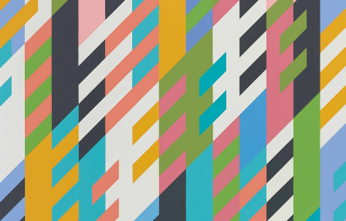
Bridget Riley
Zaria Forman
Renata Bernal
Wassily Kandinsky
Ilya Bolotowsky

