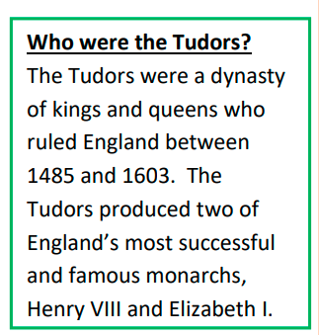
Bickerstaffe CE Primary School
Autumn 1 Class 4
History What was life like in Tudor times?

What will we learn:
Key Vocabulary
Authority | A person or ruler to give orders and make decisions for the country
Evidence | The information that historians extract from sources.
Heir | A person who inherits money, property or a title after a family member dies.
Inventory | A list of all the items belonging to a person who has died.
Primary source | An original document from the period being studied that has not been changed in a way.
Propaganda | Information given out that may not be accurate but is intended to make people believe something or hold a particular point of view.
Tyrant | A person or ruler who uses their authority cruelly.
Secondary source | A document or a record that was not written at the time of the event studied.

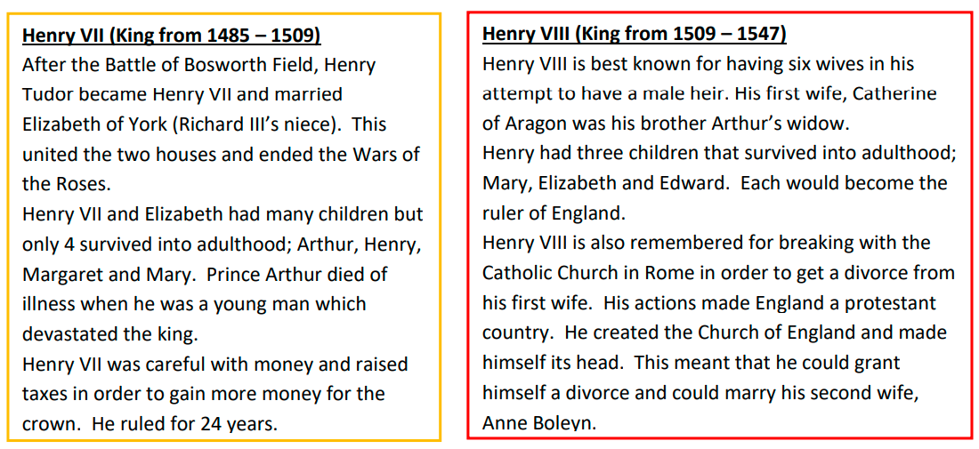

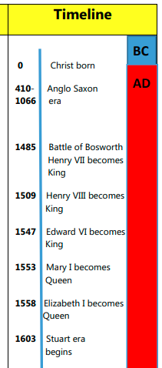

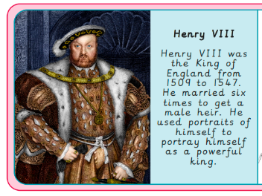
Being a Historian
- use a range of evidence to interpret events
- evaluate the usefulness and reliability of primary and secondary sources;
- address questions about change, cause, similarity and difference, and significance;
- develop a chronologically secure knowledge and understanding of British, local and world history;
- identify connections, contrasts and trends over time;



