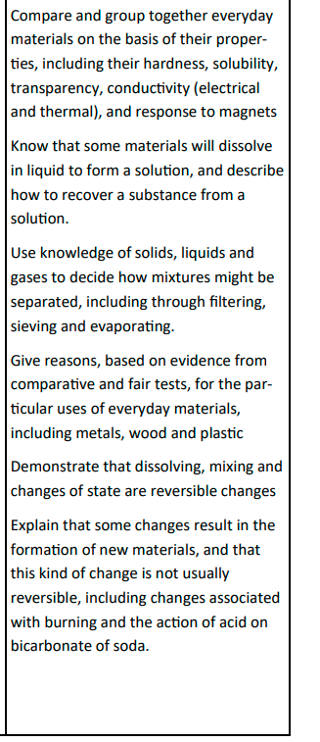
Bickerstaffe CE Primary School
Autumn 1 Class 4
Science Properties and changes in materials

Key Vocabulary
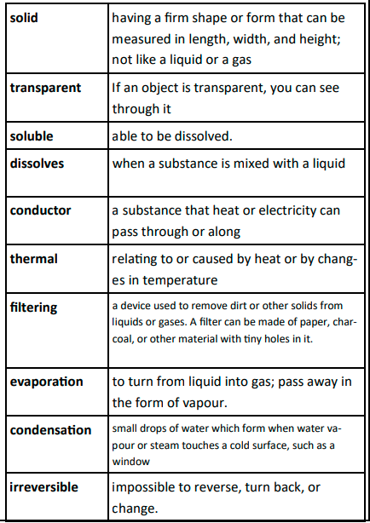
What will we learn:

Materials have different uses depending on their properties and state (liquid, solid, gas). Properties include hardness, transparency, electrical and thermal conductivity and attraction to magnets. Some materials will dissolve in a liquid and form a solution while others are insoluble and form sediment.
Mixtures can be separated by filtering, sieving and evaporation.
Some changes to materials such as dissolving, mixing and changes of state are reversible, but some changes such as burning wood, rusting and mixing vinegar with bicarbonate of soda result in the formation of new materials and these are not reversible.



