Prior Knowledge:

Bickerstaffe CE Primary
Autumn 2 Class 3 Year 4
Design and Technology– Wearable technology (Digital world)

Substantive Knowledge | Disciplinary Knowledge | Key Vocabulary
What we will learn: | How we will learn: | Key words:
- We will learn to give a brief explanation of the digital revolution and/or remember key examples.  - We will be able to suggest a feature from the virtual micro: bit that is suitable for the product.  - We will write a program that initiates a flashing LED panel, or another pattern, on the virtual micro: bit when a button is pressed.  - We will identify errors, if testing is unsuccessful, by comparing their code to a correct example.  - We will learn how to explain the basic functionality of their finished program.  - We will suggest key features for a way to attach the product to the user, with some consideration for the overall theme and the user.  - We will create annotated diagrams to help illustrate how their product is worn.  - We will describe what is meant by ‘point of sale display’ with an example.  - We will follow basic design requirements using computer-aided design, drawing at least one shape with a text box and bright colours, following a demonstration.  - We will evaluate our design using a focus group. | We will problem solve by suggesting potential features on a micro:bit and justifying my ideas.  We will draw and manipulate 2D shapes, using computer-aided design, to produce a point of sale badge.  We will develop design ideas through annotated sketches to create a product concept.  We will develop design criteria to respond to a design brief.  We will follow a list of design requirements.  We will write a program to control (button press) and/or monitor (sense light) that will initiate a flashing LED algorithm.  We will analyse and evaluate an existing product.  We will use feedback from peers to improve a design.  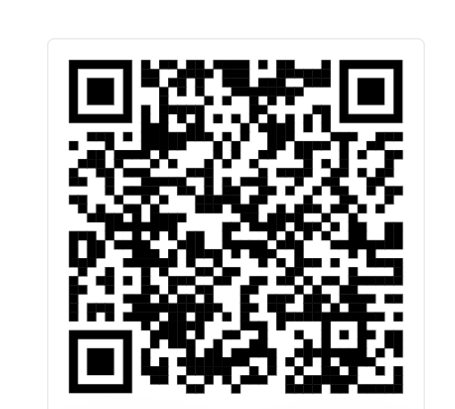
  analogue | Something that is electronic but doesn't use computer technology
  analyse | Look at something in detail.
  digital | Something that uses computer technology
  form | The shape of something
  function | What something does
  smart | A device that works on its own
  technology | Something created to solve a problem often using recent scientific discoveries
  staple | A thin piece of wire used to fasten paper together
  stencil | A shape that you can draw around.
  template | A stencil which you can use to help you draw a shape more easily on to different materials.
  Design brief | The reason to design a product

