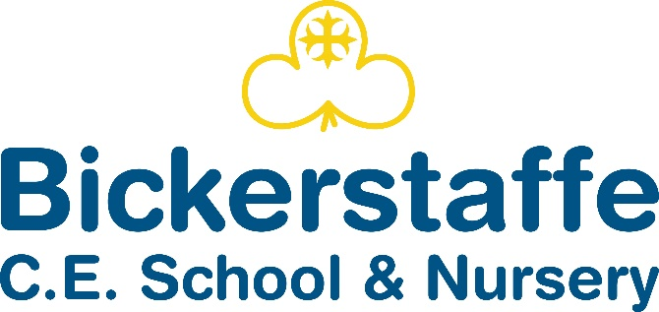

Hall Lane, Bickerstaffe, Ormskirk, Lancashire, L39 0EH
Tel 01695 722957

Headteacher – Mrs Carlin

Love each other as I have loved you…
John 15:12

School Terms and Holidays 2025-2026

Autumn Term 2025
Re-open for pupils on | Tuesday 2nd September
Mid-term Closure | Monday 27th October - Friday 31st October (inclusive)
Re-open for pupils on | Monday 3rd November
Closure at 2pm | Friday 19th December

Spring Term 2025
Re-open for pupils on | Monday 5th January
Mid-term Closure | Monday 16th - Friday 20th February (inclusive)
Re-open for pupils on | Monday 23rd February
Closure After School on | Friday 27th March

Summer Term 2025
Re-open for pupils on | Monday 13th April
May Day Bank Holiday | Monday 4th May
Mid-term Closure | Monday 25th May – Tuesday 2nd June (inclusive)
Re-open for pupils on | School reopens for children on Wednesday 3rd June
Closure at 2pm | Friday 17th July
Total for the year: 190 days
INSET Days  School Closed to Pupils |  | Monday 1st September 2025
 |  | Friday 28th November 2025
 |  | Monday 1st June 2026
 |  | Tuesday 2nd June 2026
 |  | Monday 20th July 2026
Apart from the five Teacher Training (INSET) days, school holiday dates for the academic year have been set by Lancashire County Council.

