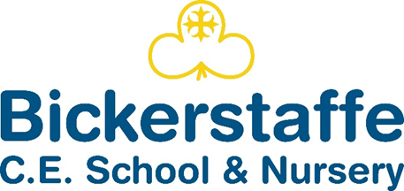
Sticky Knowledge
Substantive (what knowledge we are going to learn):
That ‘composition’ means how things are arranged on the page and shapes can be organic (natural) and irregular. | How to draw a map to illustrate a journey and choose parts of their map to inspire a range of artwork. | Art can be figurative or abstract.
How to overlap cellophane/tissue to create new colours for a stained-glass design.  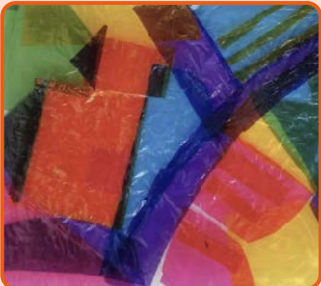 | How to print a design using ink and rollers.  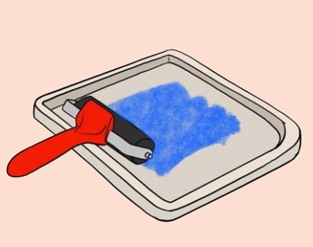 | People use art to tell stories, share important ideas or feelings, for fun or to decorate a space.
Disciplinary (the skills we will use to learn this knowledge):
Begin to generate ideas, exploring different media and techniques. | Talk about art they have seen and discuss media and techniques used. | Experiment in sketchbooks, using drawing to record ideas.
Use hands and tools with confidence when cutting, shaping and joining paper, card and malleable materials. | Create work from a design brief and inspiration from artists and their techniques. | Explain their ideas and share opinions about their own and others’ artwork.

Vocabulary
abstract | Art that doesn’t necessarily look like what inspired it.
composition | Putting elements together in a nice way.
curate | Someone who works in a gallery, and looks after and organises art work.
inspired | Feeling excited and interested by something you have seen.
negative print | When ink shows the background of the tile and not what was drawn on it.
pattern | A design where shapes, colours or lines are repeated.
stained glass | Coloured, decorative glass in a design.
view finder | A tool used to help focus on one part of a design.

Bickerstaffe CE School and Nursery Knowledge Organiser
Autumn 1 Class 2
Art - Craft and Design- Map it Out

