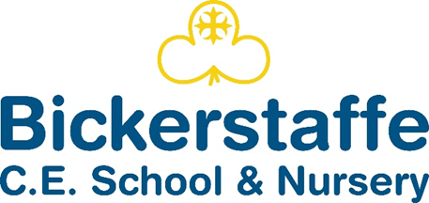
Sticky Knowledge
Substantive (what knowledge we are going to learn):
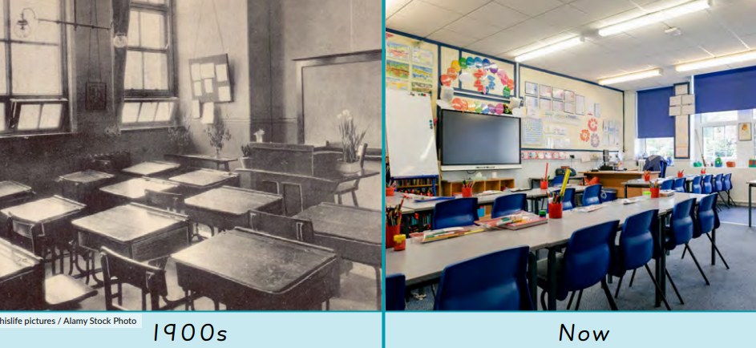  To know that daily life has changed over time but that there are some similarities to life today. | To know that there are explanations for similarities and differences between children’s lives now and in the past. | To know that we can find out about how places have changed by looking at maps.
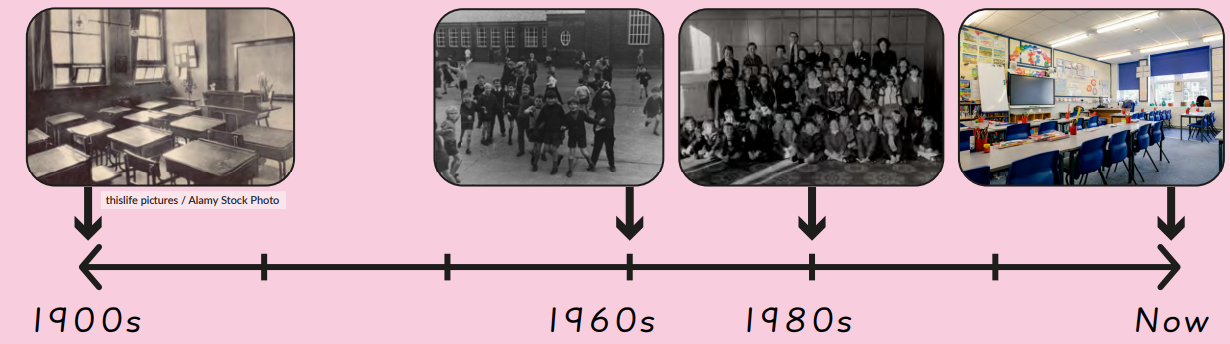  To know that a timeline orders events and that a decade is ten years. | To know that beyond living memory is more than 100 years ago. | To know that historians use evidence from sources to find out more about the past.
Disciplinary (the skills we will use to learn this knowledge):
Sequencing photographs, focusing on the intervals between events. | Recognising some things have changed or stayed the same as the past. | Identifying similarities and difference between ways of life at different times.
Making comparisons with their own lives. | Using photographs and asking questions to find out about the past. | Expressing a personal response to historical events through discussion, drawing or writing.

Vocabulary
beyond living memory | Events that people alive today cannot remember.
decade | Ten years
different | Not being the same.
living memory | Events remembered by people who are alive.
modern | Linked to present times.
past | Time that has already happened.
present | Time happening now.
similar | Like something else.
timeline | A line showing events in time order.

Bickerstaffe CE School and Nursery Knowledge Organiser
Autumn 1 Class 2 Year 2
History – How were schools different in the past?

