
Sticky Knowledge
Substantive (what knowledge we are going to learn):
All objects are made from one or more materials. | Objects are made from materials with the right properties, like plastic being waterproof or glass being transparent. | Some objects can be made from different materials, such as: plastic, glass, or metal cups.
Materials have more than one use, for example: Wood can be used for furniture, toys and pencils. | Some materials can change shape more easily than others, for example: Clay, fabric or rubber can be bent, squashed, twisted or stretched. | There are significant individuals (scientists) in science who have invented or discovered things that have a big impact on our lives.
Disciplinary (the skills we will use to learn this knowledge):
Ask simple questions and recognise that they can be answered in different ways | Observe closely, using simple equipment. | Begin to design their own tests to investigate the answer to a given question
Perform simple identifying and classifying, grouping task, and begin to group using prior knowledge. | Use observations and ideas to suggest answers to questions, using simple sentences to describe the answer to a question. | Gather and record data to help in answering questions, using given tables or data formats drawing own tables, deciding how to record

Vocabulary
wood | Wood comes from trees. It is strong and used to make furniture and toys.
plastic | Plastic is made by people in factories. It can be soft or hard and is used for bottles, toys, and bags.
glass | Glass is made by heating sand. It is clear and smooth. We use it in windows and bottles.
brick | A brick is a hard block made by people using clay. It is used to build houses and walls.
rock | A rock is a hard, natural material from the ground. It can be big or small.
paper | Paper is made from trees by people. We use it to write and draw on.
cardboard | Cardboard is thick paper. It is made by people and used to make boxes and packaging.
metal | Metal is a strong, hard material that is often shiny. It is used to make things like coins, cars, and tools.

Bickerstaffe CE School and Nursery Knowledge Organiser
Autumn 1 Class 2 Year 2
Science – Everyday Materials

Natural or Man-made
Wood – Natural (comes from trees)

Plastic – Man-made (made in factories from oil)

Glass – Man-made (made by heating sand)

Brick – Man-made (made from clay and baked in ovens)

Rock – Natural (found in the ground)

Paper – Man-made (made from wood or recycled materials)

Cardboard – Man-made (made from layers of paper)

Metal – Natural, but changed by people (comes from rocks called ores, then changed in factories)

Materials
A material is what something is made from
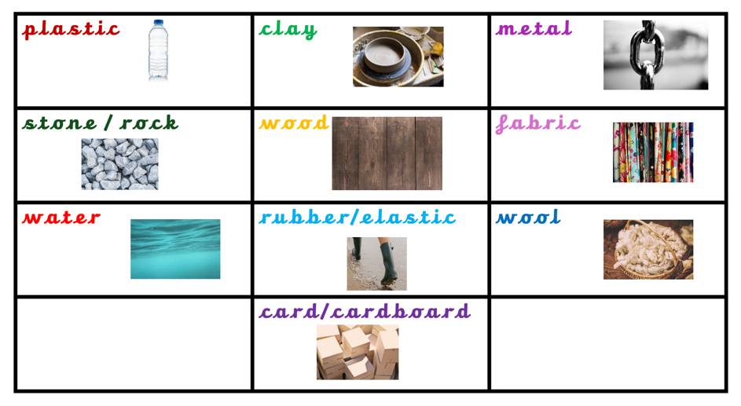

Properties of Materials
A materials property is how you describe what it can do or what it looks like.

