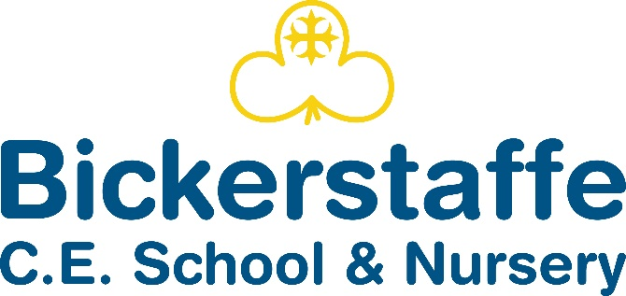

Hall Lane, Bickerstaffe, Ormskirk, Lancashire, L39 0EH
Tel 01695 722957

Headteacher – Mrs Carlin

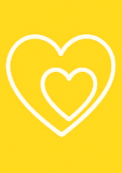
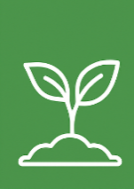
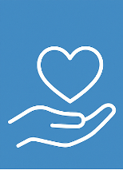

Love Serve Grow
Early Years Policy 2025-2026
Aims

This policy aims to ensure:
• That children access a broad and balanced curriculum that gives them the range of knowledge and skills needed for good progress through school and life.
• Quality and consistency in teaching and learning so that every child makes good progress and no child is left behind.
• A close working partnership between staff and parents and/or carers.
• Every child is included and supported through equality of opportunity and anti-discriminatory practice.

Legislation
This policy is based on requirements set out in the ‘Statutory framework for the Early Years Foundation Stage (EYFS)’ (September 2025).

The Curriculum (Please see EYFS Long Term Plan)

Our EYFS Curriculum has been designed to reflect the nature of our beautiful environment, the seasons of the year and the nature around our school. It aims to teach the children how their environment compares to other places, cultures and nature in other parts of the world.
The EYFS curriculum has been written in accordance with the latest version of the ‘Statutory framework for the Early Years Foundation Stage (EYFS)’ (September 2021). The EYFS framework includes seven areas of learning and development that are important and interconnected:
- Communication and language
- Personal, social and emotional development
- Physical development
- Literacy
- Mathematics
- Understanding the world
- Expressive arts and design
However, the first three areas in the list above, known as the prime areas, are seen as particularly important for igniting curiosity and enthusiasm for learning, and for building children’s capacity to learn, form relationships and thrive.

We have developed the curriculum giving communication and language skills a high priority. This is in line with Development Matters 2020: “The development of children’s spoken language underpins all seven areas of learning and development. Children’s back-and-forth interactions from an early age form the foundations for language and cognitive development. The number and quality of the conversations they have with adults and peers throughout the day in a language-rich environment is crucial. By commenting on what children are interested in or doing, and echoing back what they say with new vocabulary added, practitioners will build children’s language effectively.”

A high priority is also given to the teaching of reading. We aim to teach children to read and develop a love of books as soon as they arrive at Bickerstaffe School, and books are used to teach topics and to enhance our whole curriculum.
We follow a systematic approach to phonics teaching based on the Read Write Inc. scheme.

We underpin our curriculum with the Personal Social and Emotional Development of all our children. We strive to enable children to be safe, happy, confident individuals. We also encourage self-regulation as much as possible and introduce rules and boundaries through modelling good behaviour and reflection time.
The EYFS Curriculum is based around cross-curricular topics. Each topic planned is included in the curriculum for specific reasons and we want to ensure that all children leave the Reception Year ready to start the KS1 curriculum. Topics are introduced with a good quality storybook or age-appropriate non–fiction text, based on Pathways to Write. Using books in this way teaches children that books and reading form the basis of all learning.

Assessment

During the first term in Reception, the teacher assesses the ability of each child using a mixture of the statutory government baseline and also through teacher observations. These assessments allow us to identify patterns of attainment within the cohort, in order to adjust the teaching programme for individual children and groups of children. We record each child’s level of development throughout the year and record whether each child is on track or not on track to meet a Good Level of Development (GLD) at the end of the year in July.
Children will be judged at either an emerging level or an expected level in each early learning goal. We make regular assessments of children’s learning, and we use this information to ensure that future planning reflects identified needs.

Parents receive an annual written report that offers detailed comments on each child’s holistic progress across all areas of learning. It highlights the child’s strengths and development needs, and gives details of the child’s general progress. We complete these in June, and send them to parents in early July each year.

Inclusion

All children will receive quality first teaching on a daily basis and activities will be differentiated accordingly. In addition to this, where children have been identified as having a specific need, intervention programmes will be implemented.

Safeguarding and Welfare Procedures

It is important to us that all children in the school are ‘safe’. We aim to educate children on boundaries, rules and limits and to help them understand why they exist. We provide children with choices to help them develop this important life skill. We help children to self-regulate and manage their emotions appropriately and Personal Social and Emotional Education is at the heart of everything we do.

Children should be allowed to take risks, but need to be taught how to recognise and avoid hazards. We aim to protect the physical and psychological well-being of all children. We know that children learn best when they are healthy and safe, when their individual needs are met and when they have the chance to build positive relationships with the adults around them and their peers.

The rest of our safeguarding and welfare procedures are outlined in our safeguarding policy which have been written in accordance with ‘Keeping Children Safe in Education 2021’.

- We are a healthy school and participate in the free fruit and milk for under-fives scheme. For our Reception children we provide the universal infant free school meal and the menu is regularly monitored with the school kitchen staff. We cater for those children who have special dietary requirements and have robust systems in place ensuring that all children receive the correct meal. We make sure that children with allergies or other dietary requirements are catered for in conjunction with our catering providers.
- Fresh water is readily available for all children and we encourage children to bring in bottles so that they can help themselves to water at any time.
- Three members of staff in the setting have recognised paediatric first aid qualifications in line with the EYFS framework 2021.
- The children have lunch and breaks with the other children throughout the school. Nursery children join the rest of the school during some playtimes; they wear high-vis jackets, so they can be easily identified by the adult supervising these children.
- The class join the main school for assemblies and other whole school events.
- Reception and Nursery children have access to the indoor and outdoor eareas for continuous provision, staff are spread between the areas to ensure children are safe and are moving their learning forward.

Structure and Staffing of the EYFS

- The EYFS at Bickerstaffe consists of two classes, Reception and Nursery (3-4 year olds). We have two part-time teachers and 2 teaching assistants in reception, and two full time level 3 teaching assistants, one is a HLTA.
- Specialist teachers are brought in for some PE lessons and Spanish once a week.
- Reception children can arrive into the classroom at 8:45 a.m every morning and nursery children arrive at 9:00 am. All children are picked up at 3.25pm.

Parental Involvement

We recognise that parents/carers are children’s first educators and we value having a positive relationship with them in their child’s education through:
✓ Making contact with parents/carers before their child starts school or nursery at our parent walkabouts, induction sessions, welcome packs and home visits.
✓ Inviting parents to phonic and reading workshops/ lesson observations to see how their children will begin learning and how they can support them.
✓ Operating an open-door policy for parents/carers with any queries or concerns. Conversely, if EYFS staff have concerns about the progress of a child, they will approach parents and carers to discuss them.
✓ Written contact through Class Dojo, Twitter
✓ Offering two, parent-teacher consultation meetings per year at which their child’s progress and wellbeing is discussed.
✓ Sending a written report on their child’s attainment, progress and attitude at the end of their time in reception or nursery.
✓ Asking parents to sign a permission form for visits, food-tasting and photographs etc.
✓ Parents are invited to a range of activities throughout the school year such as special events, workshops, Christmas productions and sports day etc.
✓ Offering opportunities for parents and carers to visit the school as a volunteer to assist with the children’s learning e.g. hearing readers.

Transition

Starting school and nursery can be a difficult time for young children; we therefore plan this time carefully to support children with the transition and to ensure it is as smooth as possible for each child and that they settle in to their new class quickly and happily.
We have a tried and tested induction programme which includes:
- An induction session for parents so that teachers can get to know parents and carers and ask about the individual children. The teacher and head teacher gives parents practical information such as the ethos of the school, vision and values, and information about equipment and uniform needed.
- Stay and plays at the end of the summer term so that the children can get to know the teachers and school staff with their parent present.
- Home visits for new reception starters at the end of the summer term, before they start school.
When reception children transition into year 1 the teacher has time with the year 1 teacher to give them all the relevant welfare, academic and general information about all the children leaving the EYFS. The Year 1 teacher teaches the Reception children once a week in the last half of the summer term so the children can start to get to know them. One of these sessions is done in the year 1 classroom so that the children see their new classroom before the summer holidays.

