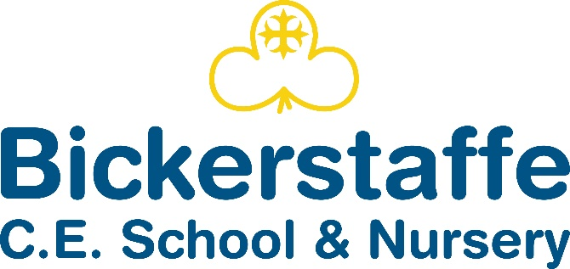

Hall Lane, Bickerstaffe, Ormskirk, Lancashire, L39 0EH
Tel 01695 722957

Headteacher – Mrs Carlin

School Terms and Holidays 2026-2027

Autumn Term 2026
Re-open for pupils on | Tuesday 1st September
Mid-term Closure | Monday 26th October - Friday 30th October (inclusive)
Re-open for pupils on | Monday 2nd November
Closure at 2pm | Friday 18th December

Spring Term 2027
Re-open for pupils on | Tuesday 5th January 2026
Mid-term Closure | Monday 15th - Friday 19th February (inclusive)
Re-open for pupils on | Monday 22nd February
Closure After School on | Thursday 25th March

Summer Term 2027
Re-open for pupils on | Monday 12th April
May Day Bank Holiday | Monday 3rd May
Mid-term Closure | Monday 31st May – Friday 4th June (inclusive)
Re-open for pupils on | School reopens for children on Monday 7th June
Closure at 2pm | Friday 16th July
Total for the year: 190 days
INSET Days  School Closed to Pupils |  | Friday 4th December 2026
 |  | Monday 4th January 2027
 |  | Monday 19th July 2027
 |  | Tuesday 20th July 2027
 |  | Wednesday 21st July 2027
Apart from the five Teacher Training (INSET) days, school holiday dates for the academic year have been set by Lancashire County Council.

